**STATEMENT OF INTENT**

VISION

The Professional Services Review (**PSR**) scheme was established in 1994. Part VAA of the *Health Insurance Act 1973* (HIA), which establishes the agency, defines the basic purpose of the scheme as protecting:

***‘patients and the community in general from the risks associated with inappropriate practice’***   
[and]***…‘the Commonwealth from having to meet the cost of services provided as a result of inappropriate practice.’***

PSR is an important part of the wider framework established to safeguard the Australian public from the risk and cost of inappropriate practice within the Australian Government’s Medicare Benefits, Dental Benefits, and Pharmaceutical Benefits Schemes. Whilst PSR is an independent agency, it remains mindful of the specific role it plays in the broader compliance framework, and works actively with the Department of Health (**Department)** and stakeholders to focus on consultation and compliance with government policy.

**PSR’s vision and values**

Our vision represents the overarching goal of PSR as a contributing agency to Australia’s health system:

***‘Excellence in ensuring Australia’s health system meets the expectations of the Government and community’***

Underpinning this vision are value statements that guide the activities of the agency.

PSR recognises its responsibilities as a part of the broader Australian Public Service (APS). As a statutory agency, PSR is committed to the Australian Public Service Values and the Code of Conduct outlined in the *Public Service Act 1999*.

The agency vision is reinforced by our values, of being ‘Fair, transparent and professional’ in the way we operate.

To achieve these values PSR commits to:

* procedural fairness
* a consistent approach to reviews
* to be effective and impartial in decision-making
* to have transparency in outcomes
* to explain the process to stakeholders
* to inform those under review of their rights and responsibilities
* to share information about the scheme, our outcomes and activities
* to comply with Commonwealth legislative requirements and expectations.

**Procedural fairness**

PSR is a late stage of the compliance pathway designed to safeguard the Medicare, Dental and Pharmaceutical Benefits Schemes. The compliance pathway starts within the Department, and only a small number of the practitioners screened and reviewed by the Department are referred on to PSR. Figure 1A depicts the integrated compliance strategy, which includes educational letters, departmental reviews and audits.

**Figure 1A**

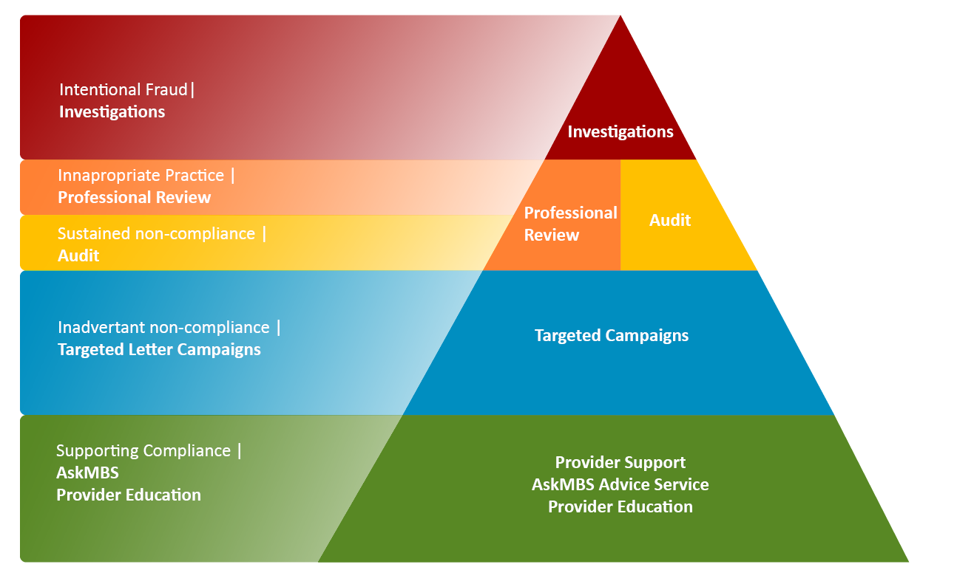**Pyramid representing outcome of compliance activities**

The PSR Scheme process is described in legislation. The process is highly regulated with a number of specified steps and opportunities for practitioners to provide input throughout the review process.

**Figure 1B.**

**Flow chart of the Professional Services Review Scheme Process**

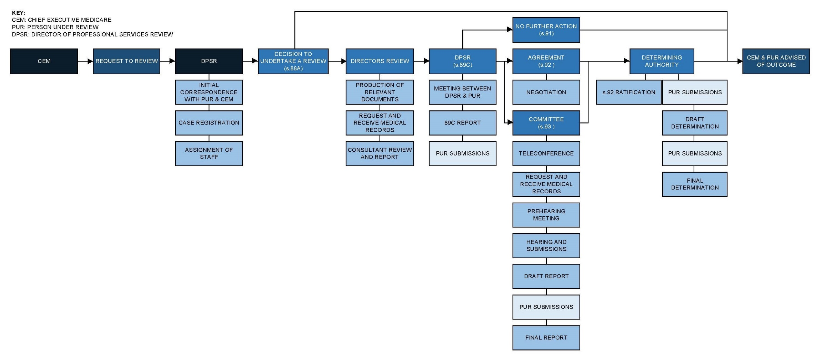

PSR strongly encourages persons under review (PURs) to have legal representation. This encouragement has been effective, with more than 95% of practitioners and employer/corporates referred to the agency being legally represented through the PSR process. Most practitioner lawyers are funded through medical and other indemnity providers and therefore do not impose a cost burden on the practitioners.

Most employers/corporates use in-house legal teams, but some do engage external counsel.

Practitioners and employer/corporates under review are given many opportunities to provide submissions, both orally and in writing, to address any concerns/issues that are identified during the review process (see Figure 1B).

In making submissions about the possible outcome of the Director’s stage of the review process, practitioners are asked to suggest a course of action for the Director to take in their written submissions. Audits of practitioner requests for outcome indicate that the majority of requests are able to be actioned.

**A consistent approach**

To achieve a consistent approach, all practitioners or employer/corporates under review receive a booklet that outlines the PSR process in detail. A copy of the booklet is available on our website at [www.psr.gov.au](http://www.psr.gov.au).

The legislation imposes a tight time limit of 12 months for the Director’s stage of the review process. This ensures that decision-making is timely.

PSR Panel members who act as peer reviewers receive annual training on topics including procedural fairness and consistency in decision-making. PSR legal staff who help peer review Committees draft decisions also receive annual training in writing quality decisions that engage with the evidence, submissions and the law.

PSR also provides external legal advisors for the Determining Authority to help the practitioner members and community representative draft consistent determinations that engage with the evidence, submissions and the law.

Whenever a matter is appealed to the Federal Court, PSR reviews the outcome and integrates any relevant learnings into subsequent training of the peer reviewers and staff.

**Effective and impartial**

The central tenet of PSR is peer review and the standard for inappropriate practice is:

***‘conduct in connection with providing services that would be unacceptable to the general body of the profession or specialty.’***

PSR recruits peer reviewers utilising a comprehensive process that involves:

* national advertising
* screening applicants for currency of practice
* standardised interviews and scoring
* social media screening
* formal consultation with the Australian Medical Association (**AMA**) or relevant professional bodies for non-medical disciplines
* formal consultation with the relevant College in the case of medical practitioners (provided under a Memorandum of Understanding via the AMA)
* consultation with the Department.

Names of recommended potential peer reviewers are then forwarded, via the Department, to the Minister who has the authority under the Act to appoint them as members of the PSR Panel.

The comprehensive appointment approach ensures that peer reviewers are highly respected members of their respective clinical communities and can impartially and effectively evaluate behaviour in a PSR review.

Peer reviewers receive orientation and thereafter annual training in their role.

Furthermore, before being appointed to a Committee to review a case, peer reviewers are specifically asked by the Director if they have any known or potentially perceived conflict of interest related to the matter.

The person under review also has an opportunity to raise a concern over potential bias in relation to a peer reviewer and the Director will consider this before the Committee peer review process commences. If a concern over bias of a peer reviewer is upheld, a different peer reviewer will be appointed to the Committee.

**Transparency of outcomes**

PSR delivers transparency in outcomes through the information detailed in its annual report, quarterly newsletters and monthly publications of case outcomes. PSR does so whilst also prioritising the protection of personal information held by the agency.

PSR’s annual report is tabled and published online every year. PSR responds to questions at Senate estimates about its operations.

The PSR Panel quarterly newsletter is a relatively new initiative, commencing in 2018. In 2019, a review was undertaken of newsletter content with feedback received from the AMA, medical indemnity providers, and the Department. A revised newsletter format was instigated from 2019. PSR Panel newsletters are published on the website and an email list is available for any interested party to request addition to the mailing list. The mailing list includes all relevant stakeholders as well as PSR Panel members.

In the past, PSR did not consistently publish case outcomes. Since 2017, the Agency has published a monthly report of the outcomes of cases on its website. Summary content has been developed in consultation with the major practitioner defence insurers, the AMA and Colleges and is reviewed biannually with stakeholders.

Matters where a section 91 outcome is made (to dismiss the review and take no further action) are not published. This is because no finding of inappropriate practice has been made.

Matters where a section 92 outcome is made (negotiated agreement between the PUR and the Director, where the PUR makes a voluntary acknowledgement of inappropriate practice) are published on the case outcomes page of the website each month. Currently the website case summaries include the discipline of the practitioner, a context to the review, the items investigated, the issues of concern and the outcome negotiated. These summaries are anonymised so as to comply with section 130 and to not reveal personal information about these practitioners.

Matters referred to a peer review Committee under section 93 and where the Committee makes a finding of inappropriate practice, are also published on the case outcomes page of the website each month. These summaries are more extensive and may involve naming the practitioner. PSR has published a policy on naming of practitioners, which was developed in consultation with the Department and the AMA .

**Explaining the process to stakeholders**

The Director of PSR engages regularly with stakeholders and meets to discuss any concerns they may have in relation to compliance. A list of key stakeholder meetings are published in the annual report each year.

The PSR website also explains the review process in detail.

PSR also has a feedback email inbox and responds to requests made by individuals about compliance where appropriate, and in other cases refers questions to the Department for a response.

PSR provides input into the AskMBS guidelines, providing feedback on how peer review Committees have interpreted an item number.

**Informing practitioners or employer/corporates of their rights and responsibilities**

PSR has several strategies to inform those referred for review of their rights and responsibilities.

Firstly, the agency publishes information on its website and in a booklet, which is provided to each person under review at the start of the PSR process.

Secondly, the agency encourages legal representation at every step of our process. We regularly engage with the indemnity insurers and their legal staff, meeting each year to discuss issues collectively, and also providing feedback to queries and contributing to articles in their newsletters to their members.

PSR communications highlight relevant rights and responsibilities of persons under review by highlighting the relevant legislation and attaching it to correspondence.

Finally, the agency has a commitment to act as a model litigant, meaning we ensure to co-operate fully with all requests and disclosures in any litigation matter.

**Sharing information about the scheme, our outcomes and activities**

The agency shares information about the scheme through the annual report, quarterly newsletters, monthly case outcomes documented on our website, regular meetings with stakeholders, and providing input into AskMBS. PSR also shares case feedback with the Department of Health compliance team every month regarding any issues identified, and meets regularly with practitioner indemnity providers and private hospital associations to share concerns.

The Director of PSR speaks at many annual conferences to share compliance outcomes with the professions. In the pre-COVID period, the Director spoke at approximately 10 national conferences per annum directly reaching thousands of members of the various professions.

The agency also publishes key points from any matter litigated in the Federal Court.

RELATIONSHIP WITH THE MINISTER AND HEALTH PORTFOLIO

PSR maintains a close relationship with the Department of Health. Specifically, PSR:

* informs the Department of key meetings with stakeholders and any resulting significant outcomes through meetings with the Deputy Secretary for Health Resourcing
* liaises with the Department in relation to statutory appointments to be made by the Minister
* advises the Department about changes that, in PSR’s opinion, would assist in improving the ability of the PSR scheme to achieve its statutory obligations
* meets with the Department’s Provider Benefits Integrity Division every two months to discuss emerging issues in Medicare and PBS compliance

Consistent with its stakeholder engagement strategy, PSR also engages and consults with:

* the AMA, through meetings of the Professional Services Review Advisory Committee (a 6-monthly forum involving PSR, the Department of Health and the AMA) as well as in regards to potential appointments to the PSR Panel and Determining Authority
* the medical defence organisations, including an annual meeting
* the medical colleges and peak representative bodies for other practitioners.

ORGANISATIONAL GOVERNANCE AND FINANCIAL MANAGEMENT

PSR upholds and promotes the APS values.

**APS values and code of conduct**

PSR recognises its responsibilities as part of the APS. As a statutory agency, and non-corporate Commonwealth entity, PSR is committed to the APS Values and the Code of Conduct outlined in the *Public Service Act 1999*.

PSR upholds and cultivates the APS values by promoting a culture where staff are treated fairly, equitably and with respect. PSR is committed to maintaining a work environment that encourages and supports all staff in raising concerns about unacceptable behaviour, is free from bullying and harassment, and provides protection to employees who report instances of suspected breaches of the Code of Conduct. PSR has made procedures for managing alleged breaches of the Code of Conduct available to staff. These procedures establish how allegations will be managed.

PSR has also defined its own values and behaviours, which are underpinned by and consistent with the APS Values. PSR’s values and behaviours (‘*fair, transparent and professional’*), address the unique aspects of PSR’s role and guide staff in appropriate behaviour.

**APS Bargaining Framework**

PSR staff remuneration arrangements are currently defined by PSR’s 2016–19 Enterprise Agreement, and the *Public Service (Subsection 24(1) – Professional Services Review Non-SES Employees) Determination 2020*.

PSR’s 2016-19 Enterprise Agreement came into effect in February 2017 and was developed in accordance with the Australian Public Service Bargaining Framework, and in line with APSC’s *Workplace Bargaining Policy 2015*, which was the prevailing bargaining policy at the time of negotiation. Consistent with the *Workplace Bargaining Policy 2015*, the terms and conditions of PSR’s Enterprise Agreement and remuneration were approved by the Australian Public Service Commissioner prior to consultation with APS staff, and proposed wage increases were offset by productivity improvements.

On 3 February 2020, prior to the expiry of PSR’s 2016-19 Enterprise Agreement, the *Public Service (Subsection 24(1) – Professional Services Review Non-SES Employees) Determination 2020* was approved, to extend the Enterprise Agreement for three 3 years in line with APSC’s current *Workplace Bargaining Policy 2018*.

PSR has also adhered to the Government’s recent decision to delay scheduled wage increases for six months. Correspondingly, PSR’s pay increase in February 2021 will be postponed until August 2021. PSR has also complied with the Government’s direction to suspend increases in remuneration, entitlements and allowances for all Senior Executive Service employees until further advice is received.

**Overseas Travel**

As PSR is a non-corporate Commonwealth entity, PSR’s use and management of public resources is governed by the *Public Governance, Performance and Accountability Act 2013* (PGPA Act), and *Public Governance, Performance and Accountability Rule 2014* (PGPA rule), and Orders made by the Minister for Finance.

PSR is aware that under the *Biosecurity (Human Biosecurity Emergency) (Human Coronavirus with Pandemic Potential) (Overseas Travel Ban Emergency Requirements) Determination 2020* (the Determination), made on 25 March 2020, an Australian citizen or permanent resident must not leave the Australian territory. PSR has and will continue to comply with this direction accordingly.

PSR acknowledges there are exemptions under the Determination that apply to citizens and residents who meet certain criteria. It is unlikely that PSR will seek an exemption for overseas travel in the foreseeable future as the exemption under section 6 and section 7 of the *Biosecurity (Human Biosecurity Emergency) (Human Coronavirus with Pandemic Potential) (Overseas Travel Ban Emergency Requirements) Determination 2020* applies to specific persons or in exceptional circumstances. These criteria do not currently apply to PSR. Should PSR staff require an exemption to travel overseas, PSR will comply with the Government’s direction and seek approval in accordance with relevant legislation and policies.

In ordinary circumstances, international travel for official business is only undertaken where other communication tools, such as teleconferencing and videoconferencing, are ineffective, and there is a demonstrated business need for the travel. Approval is sought in accordance with the PGPA Act and Rule, the Commonwealth Procurement Rules, PSR’s Accountable Authority Instructions and Financial Delegations, and *Resource Management Guide 405: Official International Travel – Use of the best fare of the day,* and other guidance from Government to ensure value for money is achieved and promotes the appropriate use and management of public resources.

TRANSPARENCY AND ACCOUNTABILITY

PSR operates as part of the Australian Government and is accountable to the Parliament, and the public through the Minister for Health, the Parliamentary Committee process and the tabling of its annual report.

PSR has an open and consultative relationship with its key stakeholders. The PSR Engagement Strategy is reviewed in January each year by the Agency Management Committee. The strategy is adjusted to reflect changing demands and circumstances. In the past 12 months, COVID-19 travel restrictions reduced the capacity for face-to-face meetings, and engagement has been managed through telephone calls, videoconferences and correspondence.

Figure 2 summarises the Engagement Strategy of the agency (effective January 2020).

**Figure 2**

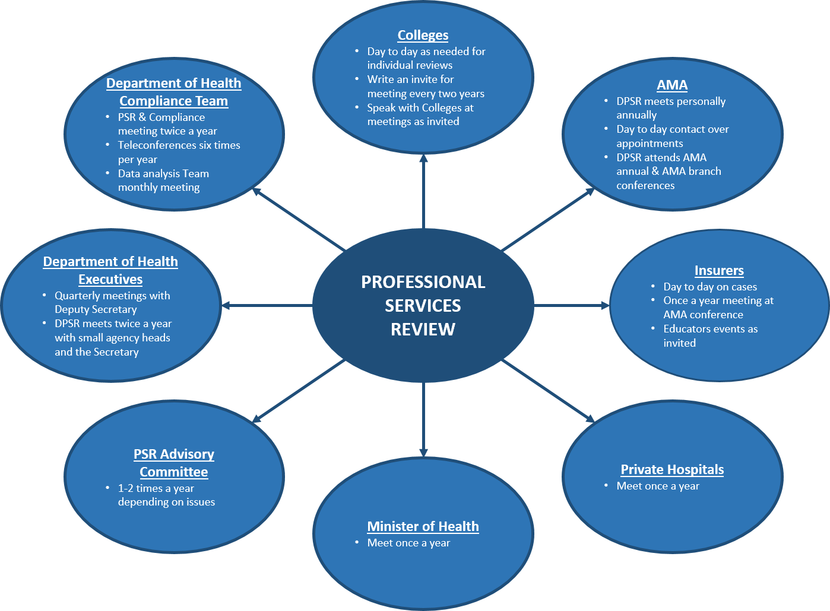**Professional Services Review Engagement Strategy**

Summary

The PSR Statement of Intent aims to promote greater transparency, accountability and information about the agency and its operations and answers the Minister’s Statement of Expectations.